Braden Licastro
Final Project Part 1
4/19/2012

In order to do this lab I decided to modify the files by making three of them a mutation probability only change, and the other three a tournament only change. For the mutation I tried 2, 4, and 6, which after reviewing the results I found that the 4% mutation yielded the highest fitness number. As for the tournaments I used the numbers 1, 3, and 5, which after review I noted that the tournament size of 1 provided the highest fitness number.

Overall changing the mutation and the tournament sizes, even just one at a time caused the results to vary. The results of the R files are as follows...

Mutation:
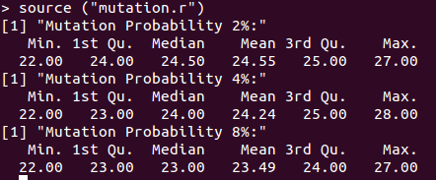

Tournament:
